3 Speed and Accident Avoidance | 3 Collisions and Momentum | Spring 2024
What students will figure out
- We can plot the speed with which a vehicle travels over time to learn more about how it is moving, including how its speed is changing.
- If you are going faster before the collision, your reaction time will not change, but your reaction distance will, because distance = speed * time.
- Some engineering solutions that can affect reaction distance include speed limits, heads-up displays, and phones that turn off notifications while driving.
Personal Glossaries
Reaction time
Materials
[Paper] Handout | Calculating Reaction Distances
[Digital] Handout | Engineering Faster Reaction Times

Calculating Speed
Review with students $y_{2}-y_{1}/x_{2}-x_{1}$

1 Discussion | Speed
Just as we graphed the position of an object over time, we can calculate and graph the speed of an object
Students use the Delta-X values discussed to calculate the speed of the car over each time interval

Interval | Δt | Δx
Δx1
Δx2
Δx3

How would the speed that the driver is going affect the position and time of the car? | We think it will take longer (time) to slow down if they are going faster. This should also tell us how far they will travel in the time it takes them to slow down (distance).

2 Graphing | Speed vs. Time
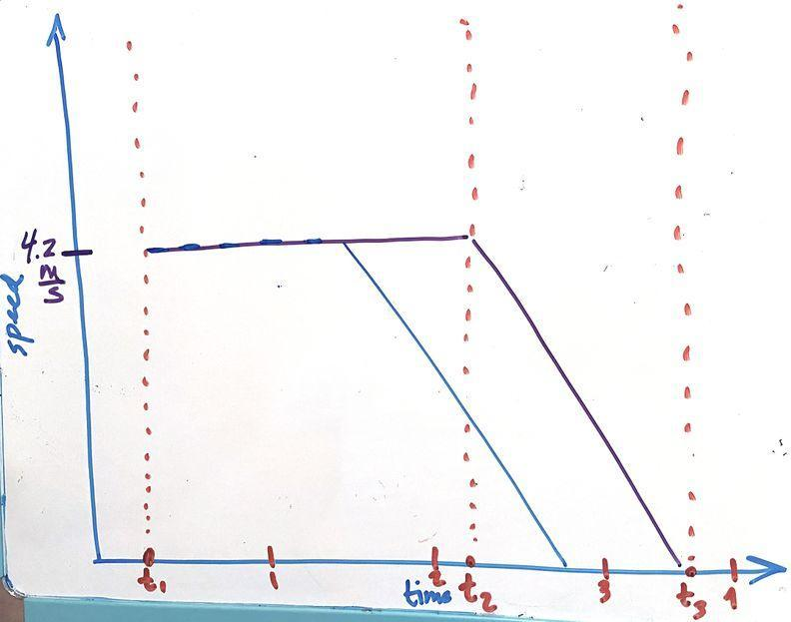
- At front of room, create a graph of speed versus time
- Students work in small groups to sketch out speed vs. time graphs in their notebooks
- What was the speed between t₁ and t₂? [Pre-obstacle time, non-distracted driver]
  - Did the speed change?
- What about between t₂ and t₃?
  - Did the speed change? To what?
- What would these values be for the distracted driver?
- How would this graph look for a driver that was speeding?
  - The Y-axis would be higher
  - The slope of the braking line should be the same
  - The distance traveled before reaching full stop would be greater

3 Investigating Speed vs. Reaction Distance
Discussion: distance = speed x time
Handout | Calculating Reaction Distances
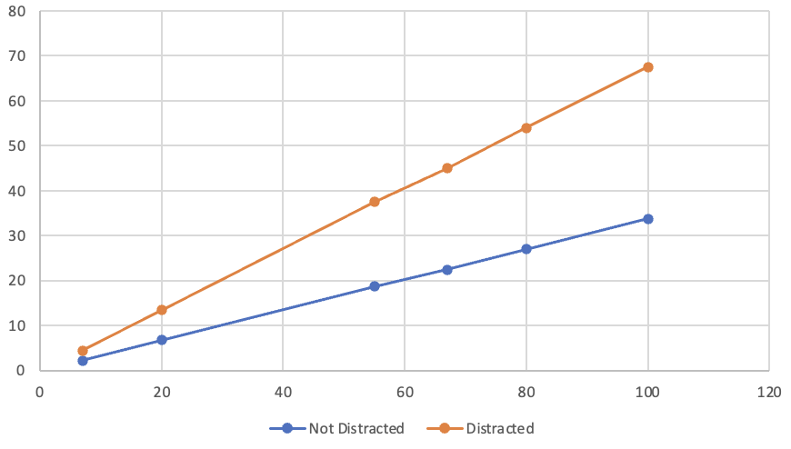

3.A Assessment | Interpreting V-T and P-T Graphs
P3L3 P-T and V-T Graphs

4 Discussion | Speed Limits
Suggested prompt | Sample student response
What did the data say about the impact of speed on reaction distance given a fixed reaction time? | Higher speeds mean longer reaction times, for both non-distracted and distracted drivers.
What evidence can you point to in your graphs to support this claim? | As the speed goes up on the x-axis, the reaction distances went up too, for both lines. It looks linear.
Was this the same for both distracted and not-distracted drivers? | Yes. But when a driver is distracted their reaction distance will be twice as long as it would have been, because their reaction time is twice as long.
What evidence can you point to in your graphs to support this claim? | As the speed goes up for the distracted driver, the reaction distance got even bigger, because everything was doubled. The slope of the distracted line is higher.
[Digital] Handout | Engineering Faster Reaction Times
Handout | Engineering Design Tracker

Lesson # | What is the design solution? | What are the new science ideas that we figured out that explain why this solution helps keep people safe? | What constraints might make it hard for engineers to apply these ideas? | How might these constraints affect some people/animals/environments differently than others?
2 | Speed limits | Driving faster means that your reaction distance will be longer. Speed limits prevent people from driving too fast. | People want to go places faster so they don’t like speed limits. Also sometimes people don’t follow the speed limit, so even if you set it people might not follow it. | It is much easier for wealthier people to pay speeding tickets, so a speed limit might not matter as much for them. Also some people might live in places with different speed limits that can affect their commute time.
2 | Heads up displays | Distracted driving means that you have a longer reaction time and less time to slow down to a stop and avoid a collision. Heads up displays let you keep your eye on the road and be less distracted. | It’s expensive and can only be put in new cars, you can’t add them to old cars. | These are only available on expensive new cars, so a lot of people won’t be able to afford them.
2 | No notifications while driving | Distracted driving means that you have a longer reaction time and less time to slow down to a stop and avoid a collision. | You can include this on a phone, but people have to opt-in. | Some people don’t opt-in, and some people don’t know about the feature.

